**Python Worksheet**

**Exercise 1:**

* 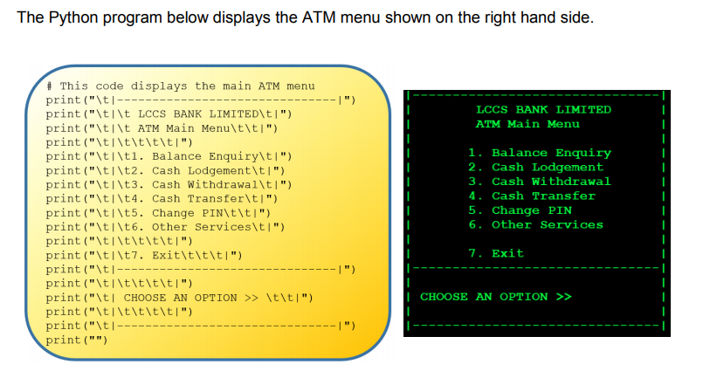Key in the code above, make sure it runs without errors.
* Make a new Python File and design and implement a menu for an application of your choice (Example: Game Instructions, Online Library Menu, Fast Food Order Screen)

You can use the space below to design it before you program.

**Exercise 2:**

There are 7 Python Assignment Statements and 7 incomplete English sentences shown below.

Match each Python statement to an English sentence.

Note: One sentence is incorrect and cannot be matched.

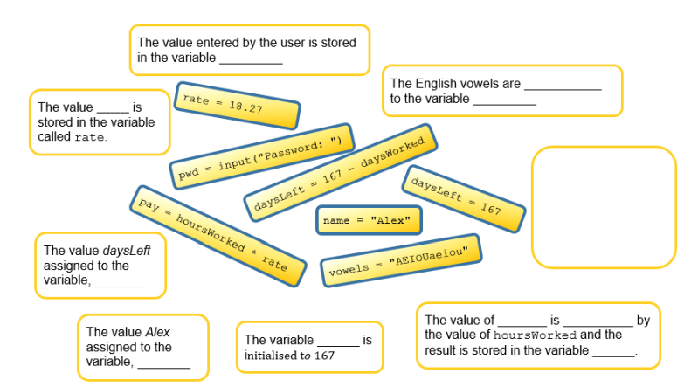

**Exercise 3:**

Which of the following are legal variable names?

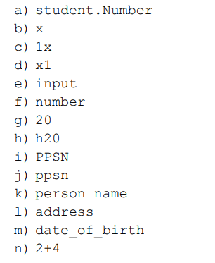

**Exercise 4:**

Look at each of the following programs.

Write what you think the output will be.

Type in each program separately and run it.

Check if you were correct.

Comment the code to say what it does (remember a comment is started with a #)

